EE311

Matlab Assignment 4 Report

Barışcan Köse 25413

Berk Açıkgöz Num

Yiğit Çatak Num

1. Create a simple noise canceling system by only subtracting a colored noise from itself. How does it perform?

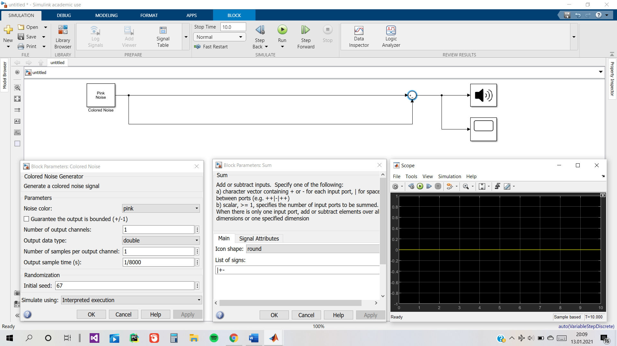

I used sum block to substract the noise from itself and used the scope block to observe the output. It was obviously 0 for all alloted time of 0 to 5 seconds. I made sure to make the number of samples per output channel of colored noise block equal to 1 and made its output sample time equal to 1/8000.

1. Then add a channel (with coefficients of [ 0.5 0.1 0.2 0.4 0 0 -0.125 0.3 0.5 0 0.075 -0.25 -0.4]) to your ANC design and report how the end result is changed.

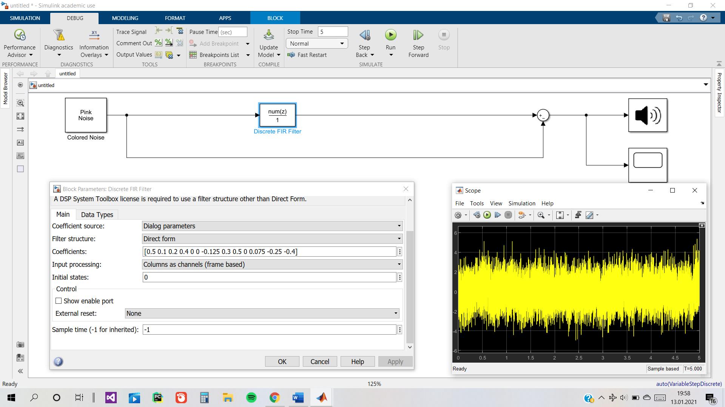

I added an Discrete FIR Filter between the sum block and the colored noise block. Coefficient source was “dialog parameters”. Coefficients were made to be the pre-determined “[ 0.5 0.1 0.2 0.4 0 0 -0.125 0.3 0.5 0 0.075 -0.25 -0.4] “ numbers. It didn’t work at all because we were substracting two very different things from each other and what we substracted was constant and it didn’t take into account the channel.

1. Now use an adaptive LMS filter (i.e. the one called “LMS Update” in simulink) for noise cancellation. How does it perform against the effect of the channel compared to the previous design?

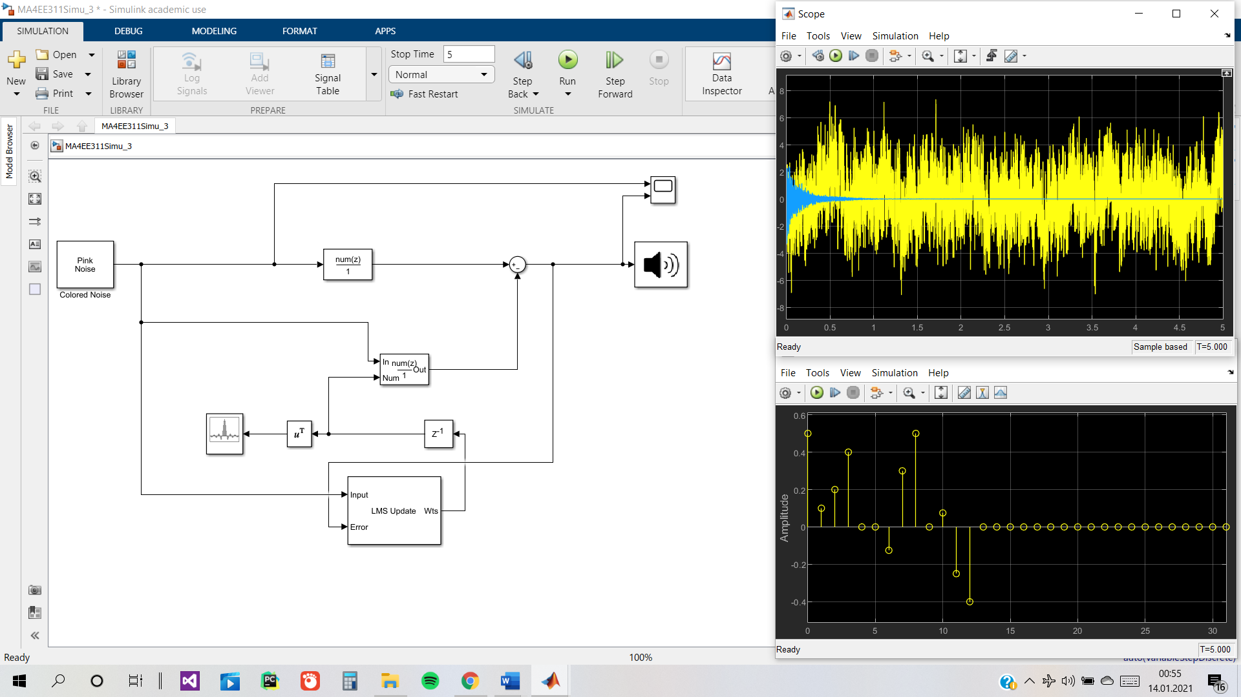

I added an LMS Update block with “Normalized LMS” algorithm and “0.05” step size. Its error was connected to the final sound and input was connected to the original noise source. The weights I got from the LMS Update were then connected to a Discrete FIR Filter with coefficient source selected to be the input port. It attenuated almost the whole sound after the first second.

1. ANC filters won’t work perfectly in real-world conditions. Therefore, to simulate this effect, add a Secondary path filter (with coefficients of [0 0 -0.5 -0.5 -0.3 0.2 -0.1 0.5 -0.5]) to your ANC filter. How did your system respond to this effect?

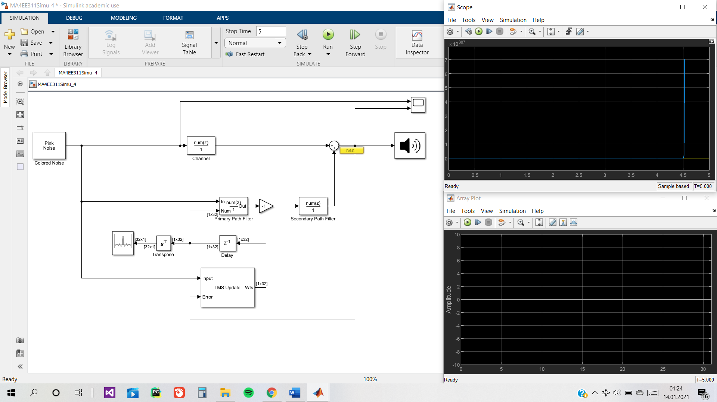I created the Secondary Path Filter by adding a Discrete FIR Filter block before the sum that gives the final sound and after the ANC Discrete FIR Filter’s Gain block. Array plot and Scope blocks were pretty much useless because of the ever-increasing sound magnitude and there was no attenuation of the sound.

1. Add a Secondary Path Estimation to your design to compensate for the Secondary Path effect. Don’t forget that you need to train your estimator before using the ANC model. Comment on the results in your report

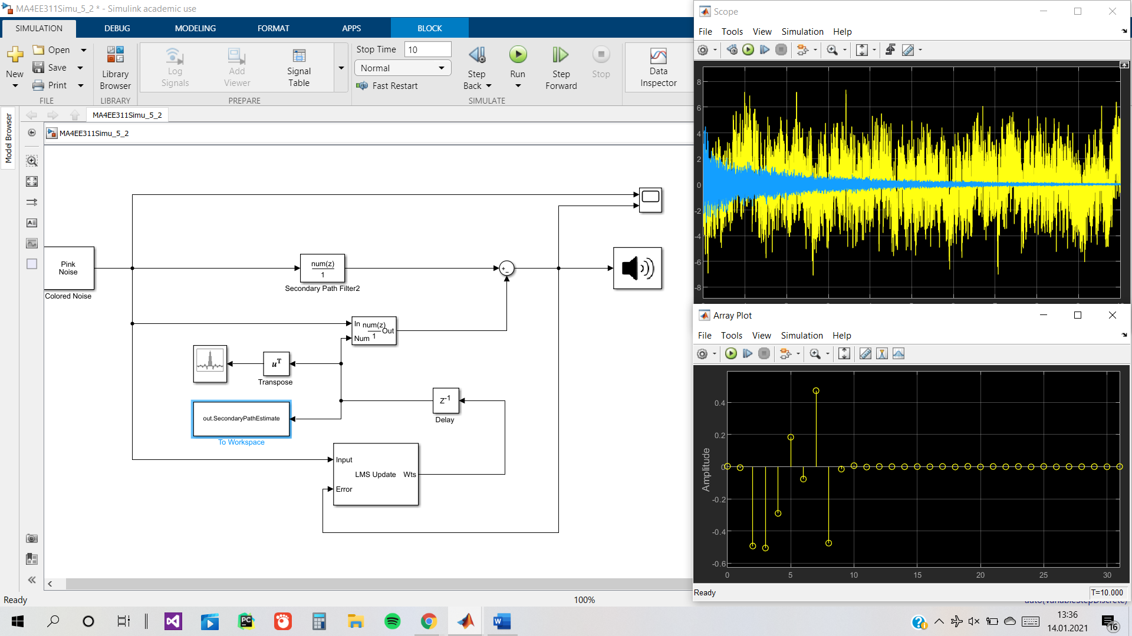In the first screenshot, you can see “To Workspace” block highlighted to show you that this model page is solely for countering Secondary Path Filter which is connected as the channel in this case. The weights that the LMS Update block produces are sent to “out.SecondaryPathEstimate” in order to be used in the next model page where we have both a channel and a Secondary Path Filter. The weights are used in the coefficients of the Discrete FIR Filter that we added between the LMS Update and the original noise source.It attenuated the sound to a respectable level but not all the way.

